Windows

All

Disable Hibernate
(also delete file “hiberfil.sys”)

powercfg -h off
(run “powercfg -h on” to turn it on)

Find running Services
Ex: net start | find /I "mySQL"

Find running Processes
(by port number)
Ex: netstat -a -o | find /I "80”

Remote desktop

Timeout settings
(User Configuration, Administrative Templates → Windows Components → Remote Desktop Services → Remote Desktop Session Host → Session Time Limits → Set time limit for active but idle Remote Desktop Services sessions)
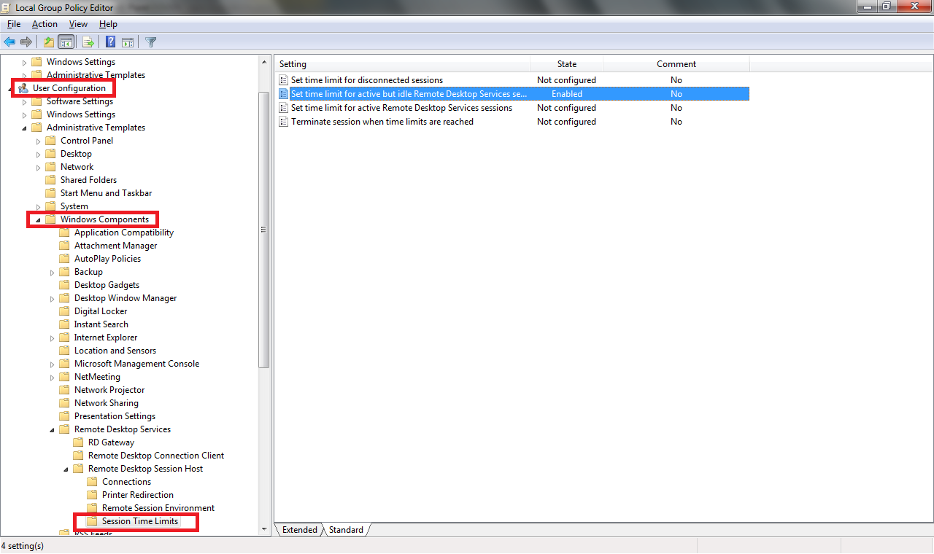
Switch from/to Full screen mode
Ctr + Alt + Break

Copy / Paste
Restart “rdpclip.exe” to make it work

Kill Process
Taskkill /F /PID <Process_Id>

Create virtual disks (subst)
Create: SUBST [drive1: [drive2:]path]
Ex:
subst E: d:\Softwares
Delete: SUBST drive1: /D
Ex:
Subst E: /D

Custom label
A custom label can^{[citation needed]} be assigned to a drive letter created in this way by way of a registry key, which can be created by renaming (select "rename" from the drive letter context menu or press F2 ) the SUBST drive in Windows Explorer/ My Computer.
HKEY_LOCAL_MACHINE\SOFTWARE\Microsoft\Windows\CurrentVersion\Explorer\DriveIcons\M\DefaultLabel\
(DefaultValue) = Your Drive Label
"M" represents the drive letter to assign a custom label to.
However, labels created for SUBST drives in this manner are overridden by the label of the host drive/partition: the custom labels are only used if the host drive has no label. One may then:
- Delete the host's drive label;
- Create the proper registry keys for the SUBST drive letter;
- Create the proper registry keys for the host drive letter (optional, works around the host drive label override caveat);
- Re-create the SUBST drive to see label changes applied

Persisting across reboots
Drive letters mapped in this way are not available during system startup for services nor do they persist across a reboot. However with a registry modification it is possible to assign a path to a drive letter during startup so it is available to system services and persists across a reboot.
Create a new registry entry "String Value" in the following key: HKEY_LOCAL_MACHINE\SYSTEM\CurrentControlSet\Control\Session Manager\DOS Devices
The name should be "X:" where X is the drive letter.
The value should be the path in the form: \??\C:\some\directory
or in form: \DosDevices\C:\some\directory
or in form: \Device\Mup\127.0.0.1\C$\some\directory
There are tools available to make the necessary changes for you.

The relative to this thematic registry key is HKEY_LOCAL_MACHINE\SYSTEM\MountedDevices It defines mapping of drive letters into particular hard disk partitions, similar to /etc/fstab on a Unix system. It also can be edited manually, but only at that time while that particular installed Window operation system is "inactive". So that, for example, if you currently boot from "D:\Windows" then you can edit the HKEY_LOCAL_MACHINE\SYSTEM\MountedDevices key of Windows that is installed in a "C:\Windows" folder, for an instance by doing the following actions:

1.run command: reg load hklm\$system C:\WINDOWS\system32\config\system
2.run command: regedit.exe
3.edit registry key HKEY_LOCAL_MACHINE\$system\MountedDevices
(that represents the HKEY_LOCAL_MACHINE\SYSTEM\MountedDevices registry key of the Windows instance that is installed in C:\WINDOWS)
4.close regedit.exe
5.run command: reg unload hklm\$system (to complete the editing procedure)
Limitations
Not all Windows processes are able to use a drive letter created in this way.[2]
Since (at least) Microsoft Windows XP SP2 Autorun.inf files present in the new drive letter are ignored; thus, AutoRun/AutoPlay does not work on drive letters created in this way. In addition, assigning a custom icon or label to the drive letter created this way via Autorun.inf does not work. A custom label assigned to the drive letter created with Subst only appears if the source drive/volume does not have a volume label set (check and set with the label command).

No need Ctrl + Alt + Del
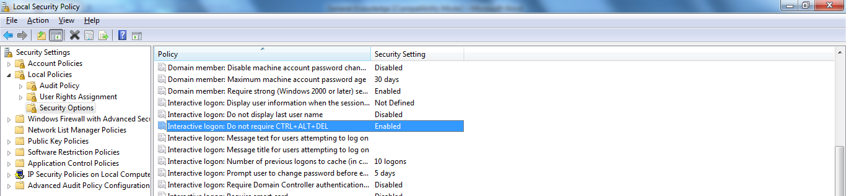

Windows XP

Control Panel (.cpl) Files
Table I. Some Control Panel Applet Files
File | Function | Tabs (number in parentheses is index n discussed below)
access.cpl | Accessibility controls | Keyboard(1), Sound(2), Display(3), Mouse(4), General(5)
appwiz.cpl | Add/Remove Programs
desk.cpl | Display properties | Themes(5), Desktop(0), Screen Saver(1), Appearance (2), Settings(3)
hdwwiz.cpl | Add hardware
inetcpl.cpl | Configure Internet Explorer and Internet properties | General(0), Security(1), Privacy(2), Content(3), Connections(4), Programs(5), Advanced(6)
intl.cpl  (Win7: control nusrmgr.cpl) | Regional settings | Regional Options(1), Languages(2), Advanced(3)
joy.cpl | Game controllers
main.cpl | Mouse properties and settings | Buttons(0), Pointers(1), Pointer Options(2), Wheel(3), Hardware(4)
main.cpl,@1 | Keyboard properties | Speed(0), Hardware (1)
mmsys.cpl | Sounds and Audio | Volume(0), Sounds(1), Audio(2), Voice(3), Hardware(4)
ncpa.cpl | Network properties
nusrmgr.cpl | User accounts
powercfg.cpl | Power configuration | Power Schemes, Advanced, Hibernate, UPS (Tabs not indexed)
sysdm.cpl | System properties | General(0), Computer Name(1), Hardware(2), Advanced(3), System Restore(4), Automatic Updates(5), Remote (6)
telephon.cpl | Phone and modem options | Dialing Rules(0), Modems(1), Advanced(2)
timedate.cpl | Date and time properties | Date & Time(0), Time Zone(1), Internet Time (no index)
Ex: control main.cpl,@0, 2 (???)
Win 8.1: main.cpl @0, 2 (verified)

Truy cap file chia se ko yeu cai user phai co password
Run → gpedit.msc
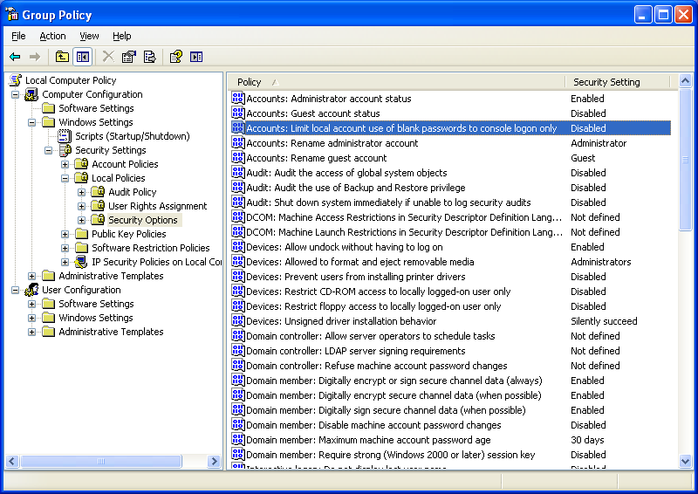

Deny logon locally
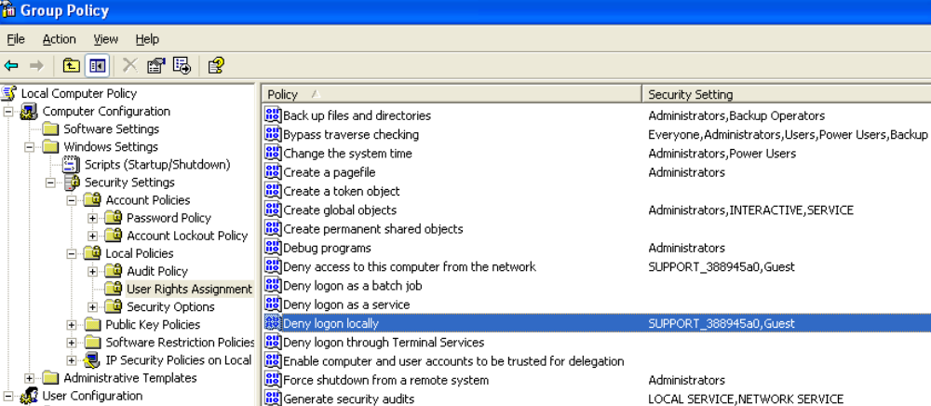

Windows 2k3

Disable the Shutdown Event Tracker
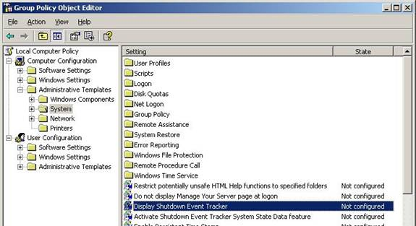

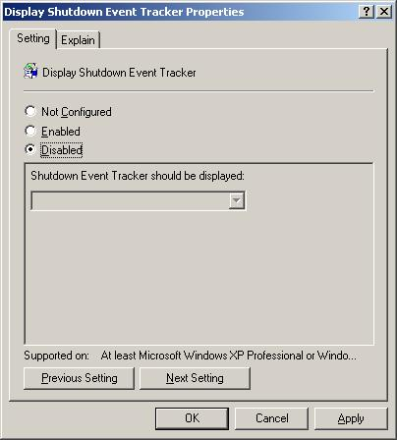

Window 8.1

Password protected sharing
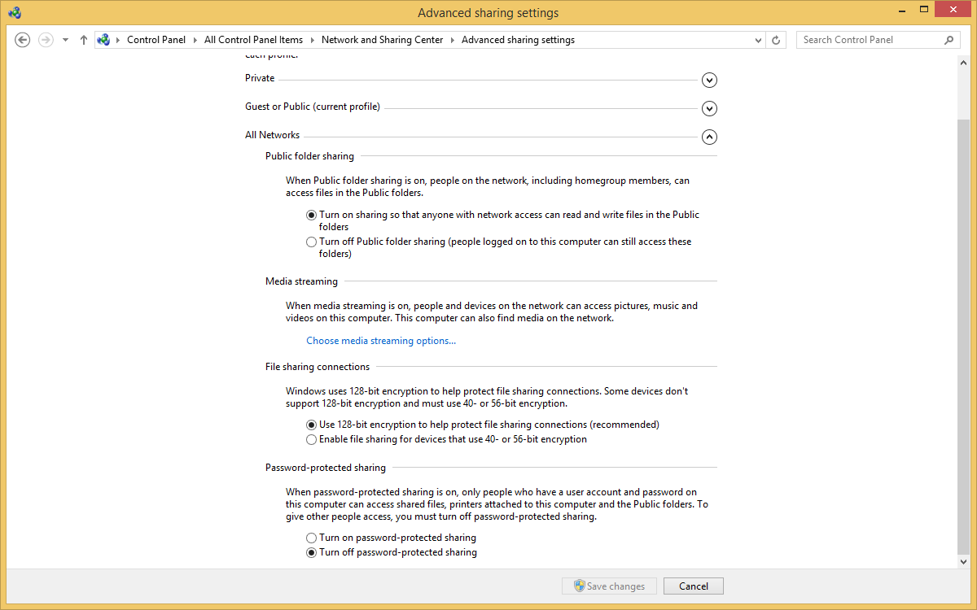

Linux

Clear memory cache
sync
echo 3 > /proc/sys/vm/drop_caches

(Try: sudo echo 3 | sudo tee /proc/sys/vm/drop_caches)

* Note: The first command writes any cache data that hasn't been written to the disk out to the disk. The second command tells the kernel to drop what's cached

* More:
To use /proc/sys/vm/drop_caches, just echo a number to it.

To free pagecache:
echo 1 > /proc/sys/vm/drop_caches

To free dentries and inodes:
echo 2 > /proc/sys/vm/drop_caches

To free pagecache, dentries and inodes:
echo 3 > /proc/sys/vm/drop_caches

As this is a non-destructive operation and dirty objects are not freeable, the user should run "sync" first!

Show Folders' size
du -hs `ls`

Vi (Vim)
(http://www.unix-manuals.com/refs/vi-ref/vi-ref.htm)

Moving cursor
^ Beginning of line
$ End of line
gg Beginning of file
G End of file
ngg (or nG) Go to line n (ex: 3gg → Go to line 3)

Deleting text
x - delete current character
dw - delete current word (after cursor)
dd - delete current line
5dd - delete five lines

d$ - delete to end of line
d0 (or d^) - delete to beginning of line

d1G - delete to beginning of file
dG Delete to end of file

Zip / Unzip

Gzip / Gunzip
Ex:

gzip -c file1.txt > /tmp/foo.gz

gunzip -c foo.gz > /tmp/file1.txt

Tar command
To create an archive using tar, use a command like this, which bundles all the files in the current directory that end with .doc into the alldocs.tar file:

tar cvf alldocs.tar *.doc

Here's a second example, which creates a tar file named panda.tar containing all the files from the panda directory (and any of its subdirectories):

tar cvf panda.tar panda/

To automatically compress the tar file as it is being created, add the z flag, like this:

tar cvzf alldocs.tar.gz *.doc

Wget (Download files)
wget [option]... [URL]...

Ex:
wget http://maven.pyramid-consulting.com/pyco-repo/org/osmoz/osmoz-base/2.1.10-RELEASE/osmoz-base-2.1.10-RELEASE.jar

Eclipse

Projects paths setting in workspace
\.metadata\.plugins\org.eclipse.jdt.ui\dialog_settings.xml
\.metadata\.plugins\org.eclipse.core.resources\.projects\<project_name>\.location

Show Whitespace characters
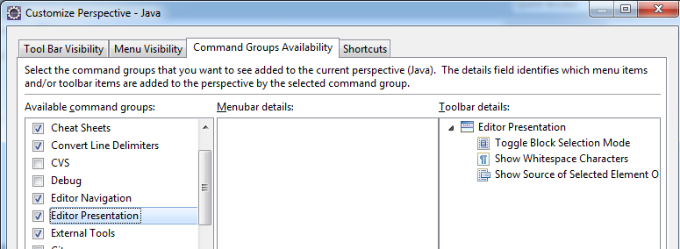

Show Selected Element Only
(See [3.2 Show Whitespace characters] for more details)
Window->Customize Perspective->Commands tab (or “Command Groups Availability”) ->Editor Presentation
(Or use shortcut: Ctrl + Shift + S)

Un-Install Plugins

Eclipse 3.6
Click Help > About and then click Installation Details... to open a dialog showing pages that provide more detail about your installation.
Click the Installed Software tab to see a list of the software items that you have installed into your system.
Select the items that you wish to uninstall.

Project Facets
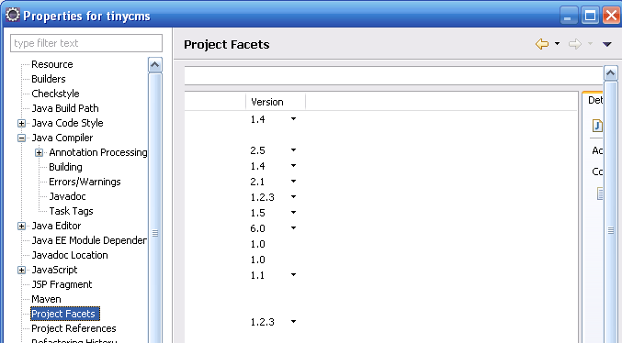

Workspace
Create a shortcut on your desktop with the following target (modified if you're using different directories):
C:\eclipse\eclipse.exe -data C:\workspace -jvmargs -Xms640M -Xmx640

Path of deployed Projects

Tomcat (plug-in)
D:\Workspace\common\.metadata\.plugins\org.eclipse.core.resources\.projects\

Editor Templates
(Java\Editor\Templates)

Logger
private static final org.apache.log4j.Logger logger = org.apache.log4j.Logger.getLogger(${enclosing_type}.class);

Warnings/Errors

Null pointer access
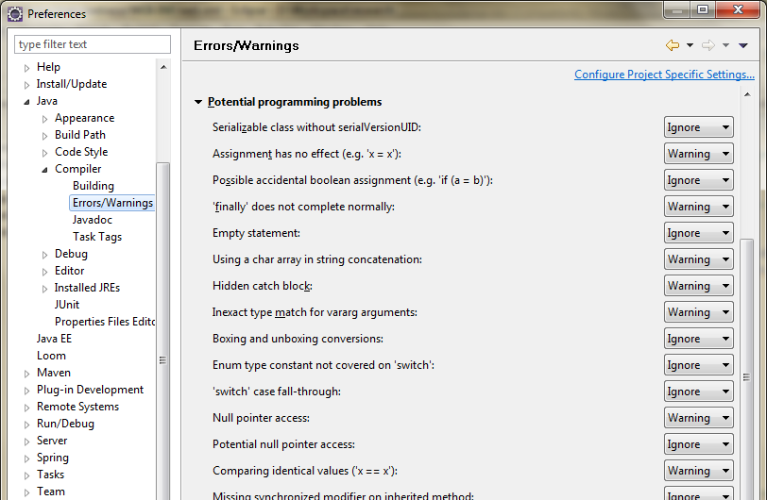

App name in Run/Debug config
<WORKSPACE>\.metadata\.plugins\org.eclipse.debug.ui\launchConfigurationHistory.xml

Maven Plugin

Solve Error: unsupported-iclasspathentry-kind-4
- Right-click on your project, select Maven -> Remove Maven Nature.
- Open you terminal, go to your project folder and do mvn eclipse:clean
- Right click on your Project and select “Configure -> Convert into Maven Project”

Missing tool.jar
Added -vm path\to\jdk\bin in eclipse.ini file
Make sure that, -vm option is placed before -vmargs as everything after -vmargs is passed directely to vm and selecting a particular depends on -vm option.
Ex:
-vm
C:\Program Files\Java\jdk1.6.0_30\bin
-vmargs
-Dosgi.requiredJavaVersion=1.6

Save before run/debug
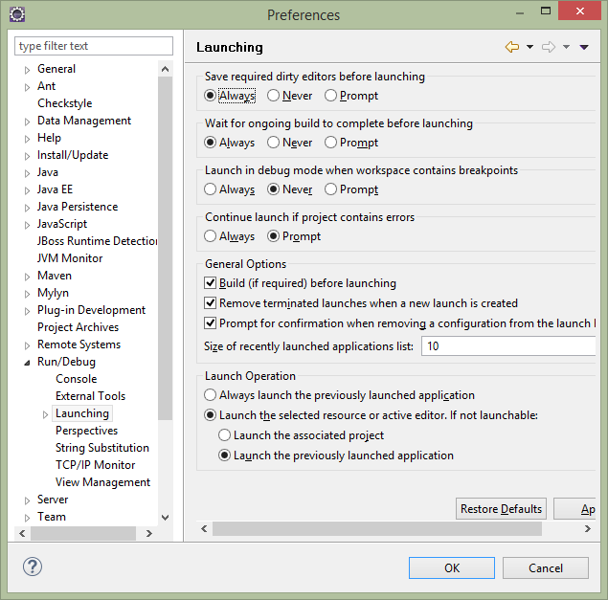

DBMS

MS SQL

SQL Server Management Studio

Save in design mode
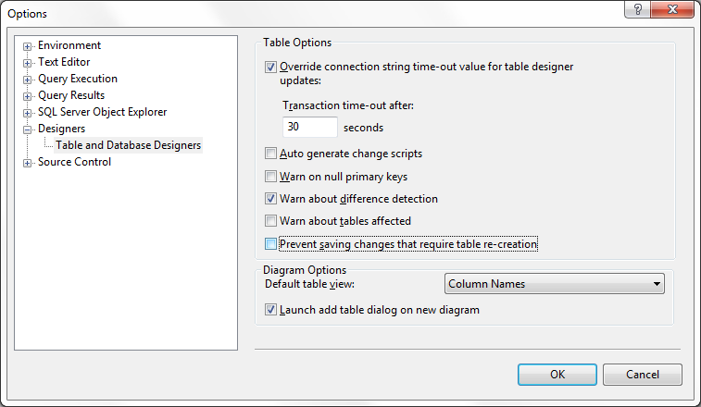

Execution timeout
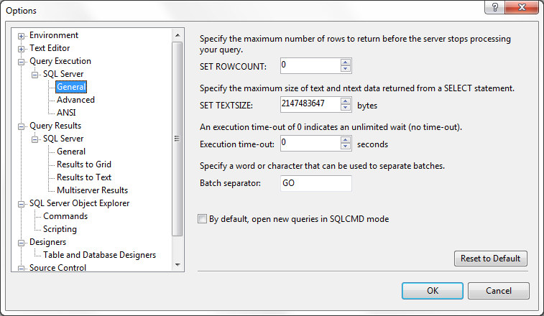

Web Server

Tomcat

contextpath
%Tomcat_HOME%\conf\Catalina\localhost

Tomcat Base
Containing these directories:
1. /conf (for server configuration files),
2. /logs (for standard log and output files),
3. /temp (used by the JVM for temporary files [java.io.tmpdir]),
4. /webapps (for the web applications that will be automatically loaded) and
5. /work (temporary working directories for web applications)

Remote debug
Just add the following VM parameters to JAVA_OPTS:
-Xdebug -Xrunjdwp:transport=dt_socket,address=8000,server=y,suspend=n

Execution order of .bat files
startup.bat --> catalina.bat --> setclasspath.bat

Apache

Create Service
- Go to Apache folder
- Run command: httpd.exe -k install -n "Apache2.4"
(Or: sc create "Apache2.4" binpath= "\"C:\Program Files\foo\bar.exe\" -service" ???)

Maven

Archetype
Create a quickStart project:
mvn archetype:generate -DarchetypeCatalog=http://tapestry.apache.org
- archetype:create creates a Maven 2 project from an archetype. It uses the behavior of the Archetype Plugin version 1.0-alpha-7.
- archetype:generate ask the user to choose an archetype from the archetype catalog, and retrieves it from the remote repository. Once retrieved, it is processed to create a working Maven project.
- archetype:create-from-project creates an archetype from an existing project.
- archetype:crawl search a repository for archetypes and updates a catalog

Generate project files

Eclipse
mvn eclipse:eclipse

Generate Web project structure
Note: Generate from an empty folder
mvn archetype:create -DgroupId=org.java.demo -DartifactId=module-struts2 -DarchetypeArtifactId=maven-archetype-webapp
Generate web project files
Go to Project folder (cd module-struts2), and issue command below:
mvn eclipse:eclipse -Dwtpversion=2.0

(After that, make sure the nature below is present in .project file:
<nature>org.eclipse.wst.common.project.facet.core.nature</nature>)

Skip compiling test-cases
mvn install -Dmaven.test.skip=true

Skip running test-cases
mvn install -DskipTests

Internet Explorer

Change default View Source editor in IE
Run REGEDIT, follow the following directions to the proper key.
HKEY_LOCAL_MACHINE
|- Software
|-- Microsoft
|--- Internet Explorer
|---- View Source Editor
|----- Editor Name (Default) = C:\windows\notepad.exe
If this doesnt exist (but it should) then create the Key "View Source Editor".
Then create a Key within that named "Editor Name". Modify the "(Default)" value to make it point towards any program on your computer using "D:\Tools\Notepad2\Notepad2.exe" (without the brackets).
[Me] – EditorName.reg
Begin----------------------------------------------------------------
Windows Registry Editor Version 5.00

[HKEY_LOCAL_MACHINE\SOFTWARE\Microsoft\Internet Explorer\View Source Editor\Editor Name]
@="C:\\Program Files\\Windows NT\\Accessories\\wordpad.exe"
End------------------------------------------------------------------

Beyond Compare

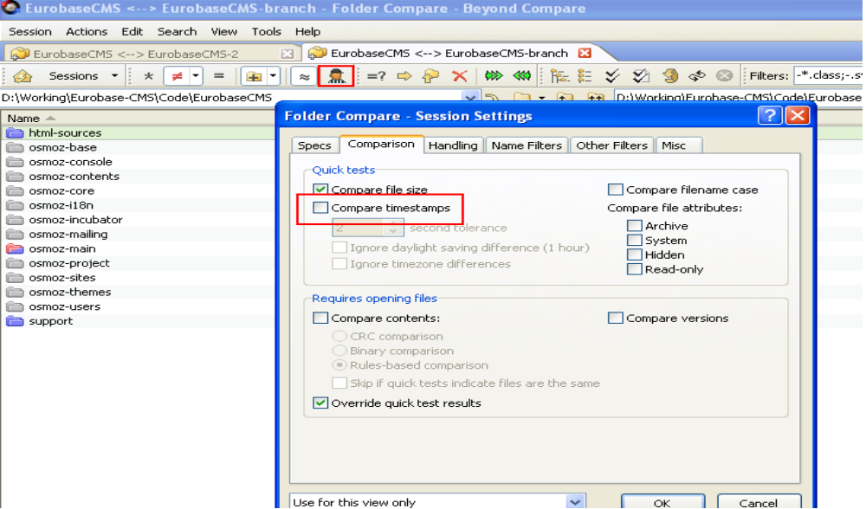
Ignore Timestamps

MS Office

Updating Table of Contents
- Select TOC
- Press F9

Updating (Multiple) Field (Cross-reference)
- Select All (Ctrl + A)
- Press F9

Total page
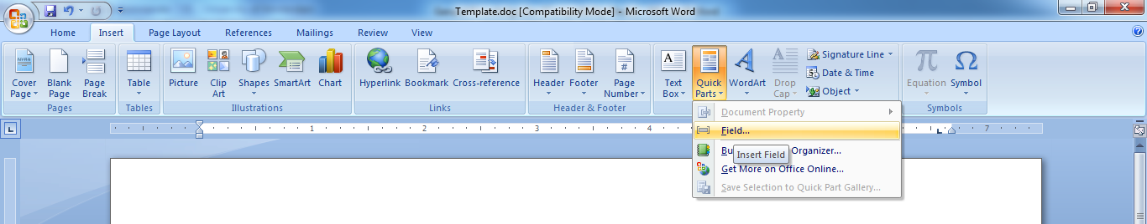

Password protect
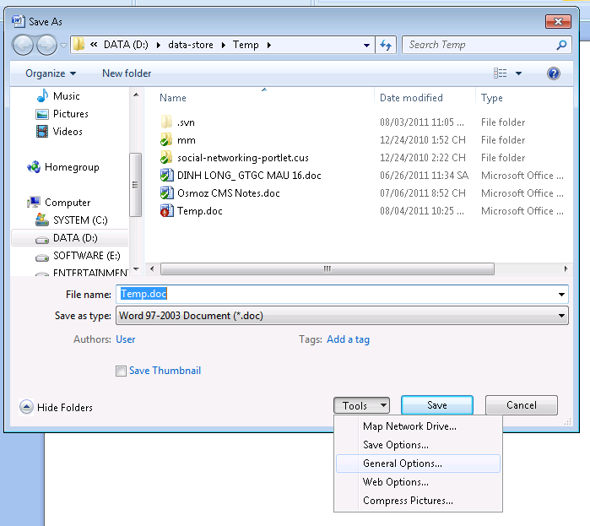

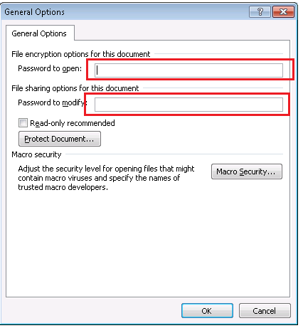

Hide number 0
Chọn các ô có số 0 cần giấu. Nhấn menu Format>Cells (hoặc nhấn Ctrl+1), chọn thẻ Number.
- Trong hộp Category, chọn Custom. Trong hộp Type, gõ 0;-0;;@

Converting PowerPoint to Word

2003
Choose File > Send to > Microsoft Word

2007
Click on the Office button > Publish > Create Handouts in Microsoft Word

2010
Select File > Save & Send > Create Handouts > Create Handouts

Special characters in Excel

New line
=CHAR(10)
Ex:
=”A” & CHAR(10) & “B”
(Remember to format cell to “Wrap text”)

Currency characters
¢ | ALT+0162
£ | ALT+0163
¥ | ALT+0165
 | ALT+0128

Replace 2 new lines with 1 new line
(Shift + 6 + p)
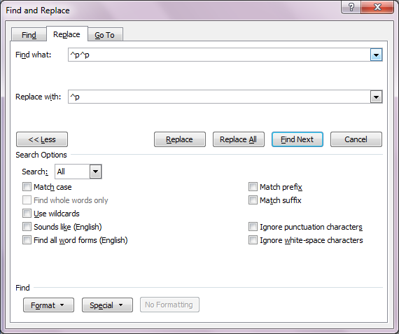

MS Outlook

Show Name When Reply Inline
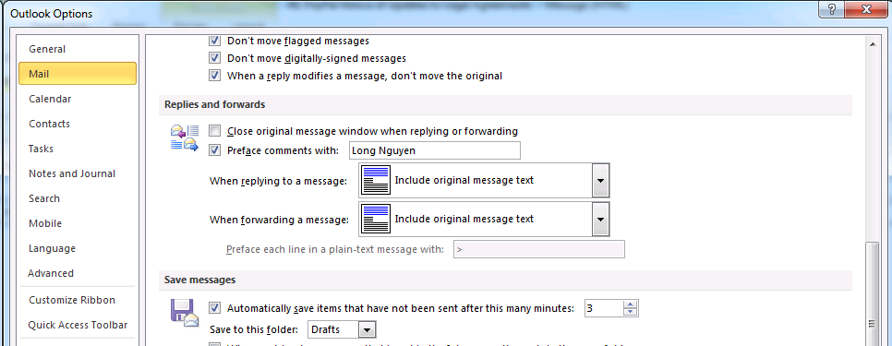

”Mark As Read” Behavior

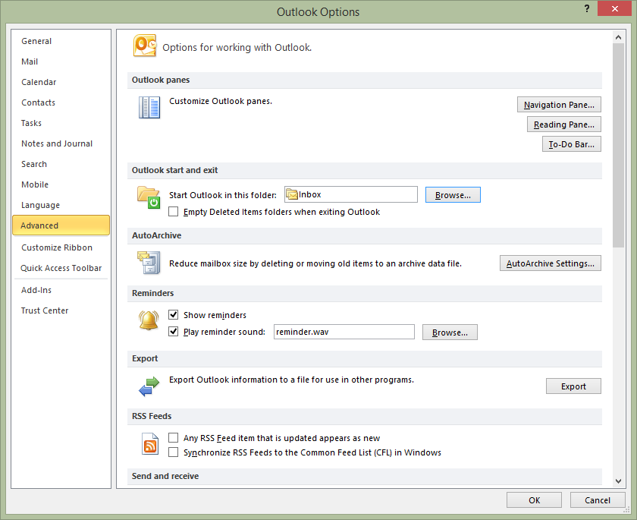

Justify issue
(Replace all ^| by ^p)
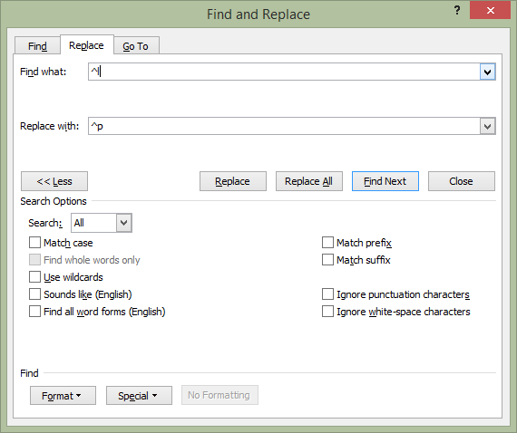

Open Office

Updating Table of Contents
- Right click on Table of Contents
- Select “Update Index /Table”

Password protect
File → Save As → Save with password

Notepad++

Yahoo

Sua loi khong dang nhap duoc
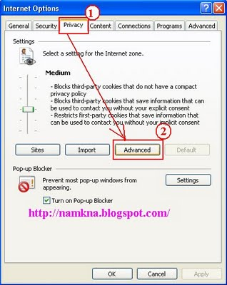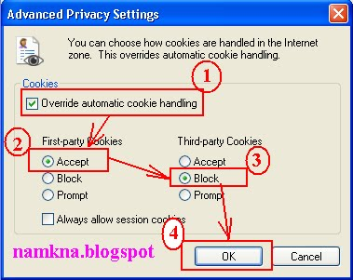

Total Commander

Shortcut keys
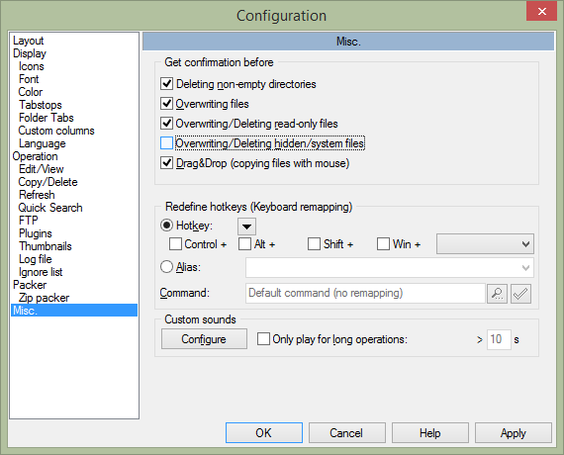

Rename File/Folder
Shift + F6

Browser

IE

Firefox

URL in new tab
- Type about:config in the address bar
- search for "browser.newtab.url"
- value : about:newtab > double click change

Reference

Video Tools
VLC (support 3D-Videos)
MKV player
RealPlayer

PDF Convertor
- WondersharePDF2WordConverter

Fake IP
- Ultrasurf
- Hotspot Shield

ETL (Extracts - Transforms - Load)
  - Pentaho Kettle - là công cụ Open Source, thành lập 2001 và sử dụng công cụ GUI để bạn xây dựng và vận hành ETL
  - Talend (opensource)
  - Informatica PowerCenter - Đây là công cụ rất tốt cho ETL dữ liệu (bản thương mại)
  - Inaplex Inaport - Nếu công ty của bạn cần ETL dữ liệu với một số các phần mềm nguồn là CRM thì Inplex Inaport có thể là một lựa chọn
  - SSIS - Dùng MS SQL Server
  - InfoSphere

Cờ thế
XQ Master

Show WIFI Password
WiFi Pass Recovery & Backup for Android
Yêu cầu: thiết bị đã root và cài đặtSuperSU for Android

Others

Print large pages

Acrobat Reader
- File → Print
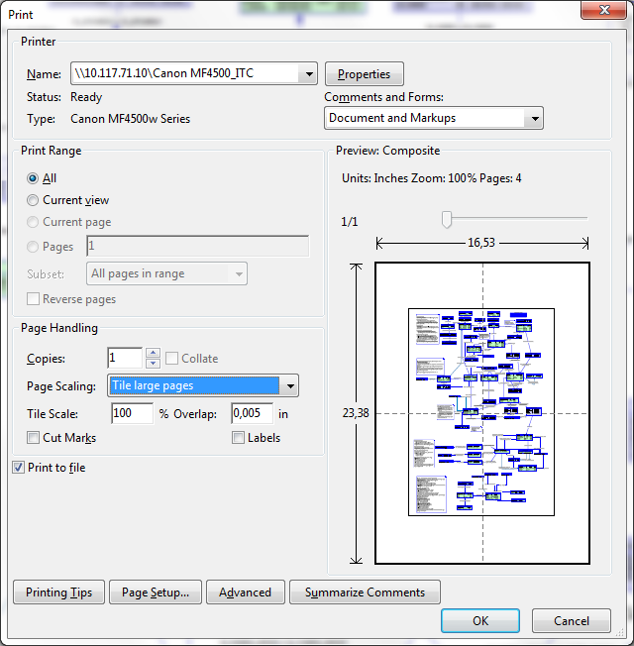

MS Paint
- Print → Page Setup
